Bahria University,

Karachi Campus



COURSE: Computer Architecture and Logic Design

TERM: FALL 2021, CLASS: BSE- 3 (B)

PROJECT NAME

Digital Counter

Group Members

Muhammad Amjad

Muhammad Ameer Hamza

Muhammad Junaid Saleem Qadri

Engr.Dr.Samar Yazdani/ Engr. Ramsha Mashood

Signed Remarks: Score:

**Table Of Content**

**Topic Page No**

1. Introduction 3
2. Circuit Diagram 3
3. Hardware Components 3
4. Working 4
5. Final picture of project 4
6. Future Work 5
7. Reference 5

* **Introduction:**

Digital counters are needed everywhere in this digital world, and [**7 segment display**](http://circuitdigest.com/article/7-segment-display) is one the best component to display the numbers. Counters are needed in [object/products counters](http://circuitdigest.com/electronic-circuits/object-counter-circuit-diagram), [digital stopwatches](http://circuitdigest.com/electronic-circuits/digital-stopwatch-circuit-diagram), calculators, timers etc. To use the 7 segment with ease, there is a 7 segment driver IC which is **IC CD4026**, so we are building **7 segment counter circuit using 4026 IC**.

* **Circuit Diagram:**

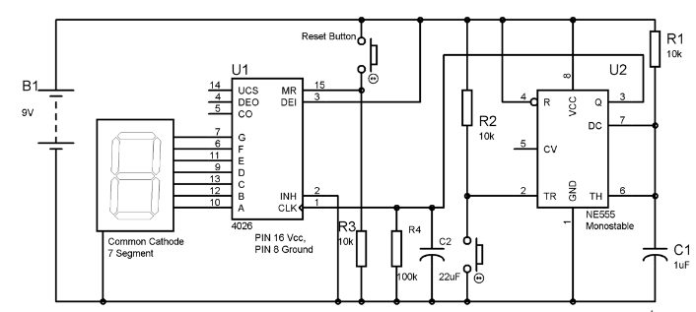

* **Hardware Components:**

1. 555 timer IC
2. 4026 IC
3. Common cathode 7 segment display
4. Two- push ON, push OFF button.
5. Resistors – 10k (3), 100k
6. Capacitor 1uF, 22uF
7. Connecting wires
8. 9 Volt Battery

* **Working:**

We have interfaced the 7 segment to the 4026 IC, PIN 4,5,14 are left open as we haven’t used them, PIN 15 used to Reset the counter with the help of a PUSH button Switch. PIN 2 is kept LOW to avoiding the freezing and PIN 13 is kept HIGH to enable the IC.

Now, the another main component of this circuit, other than IC4026, is 555 timer IC. 555 timer is used here to provide the clock pulse on each Button Press, whenever we press the button the counter advance by one. 555 Timer IC is used here in **Monostable mode**

We have also used a **RC circuit** (22uf capacitor and 100k resistor) at CLOCK PIN 1 of 4026, so that it only counts one clock pulse on each time button is pressed. Otherwise, circuit may behave unexpectedly OR it can count two or more pulses because of noise or bouncing effect of Push button.

* **Final picture of project:**

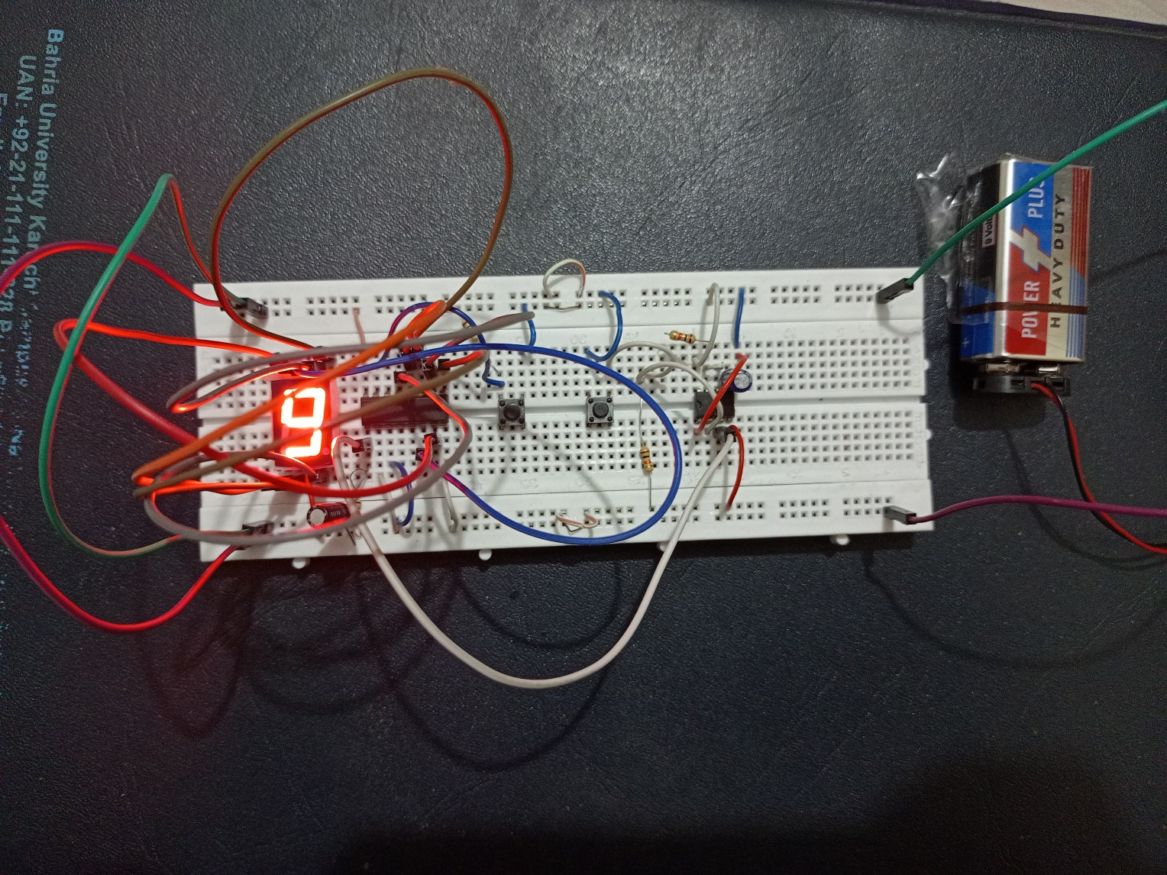

* **Future Work:**

It has been done on analog IC. In future it can be done on Micro-Controller to get better result.

* **Reference:**

https://circuitdigest.com/electronic-circuits/555-timer-seven-segment-counter-circuit